

RESOURCES – WORKBOOK
COMPUTER NETWORK
student nAME: Tiwouw, joseph Janone
inSTRuctor: Jimmy MoedjaHEDY
Universitas Klabat
airmadidi-minahasa utara
Version 1.5

RESOURCES – WORKBOOK
COMPUTER NETWORK

LINUX CENTOS

Goal
- CONFIGURE APACHE WEB SERVER

List of activity

Activities
Screen shot process to start your apache web server service
Try localhost – access web server from browser (firefox) screen shot apache test page
Create index.html file on /var/www/html (file content: your name) screen shot
Download web template (html) and put on directory /var/www/html/template/, access your template and screen shot

Answer sheet for a. configure Apache web server

1.
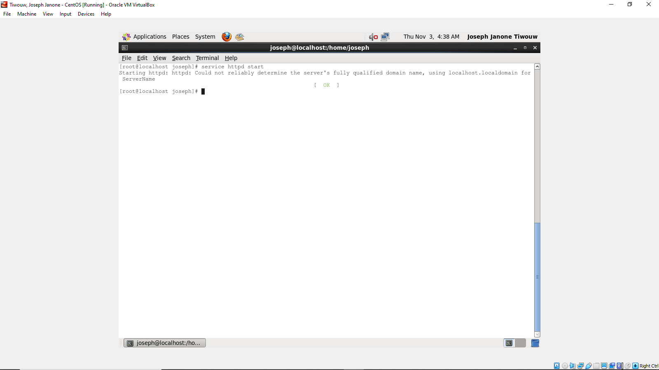

2.
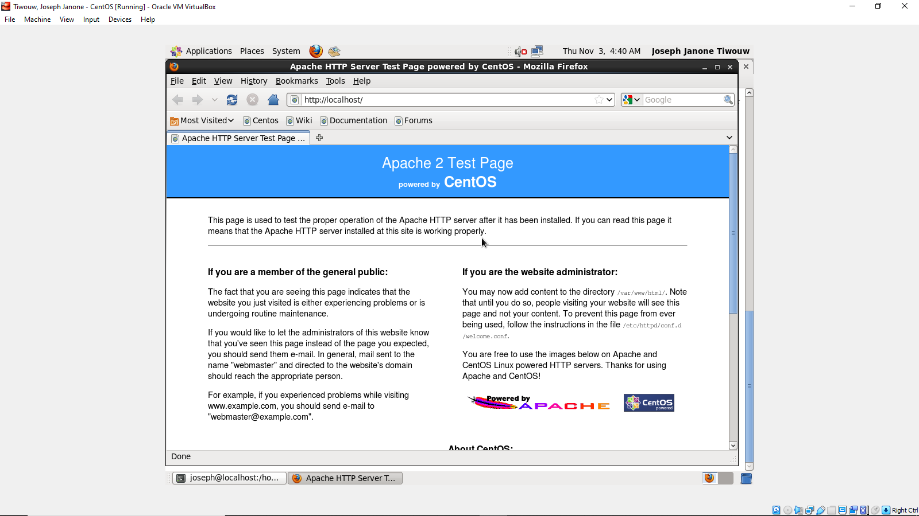

3.
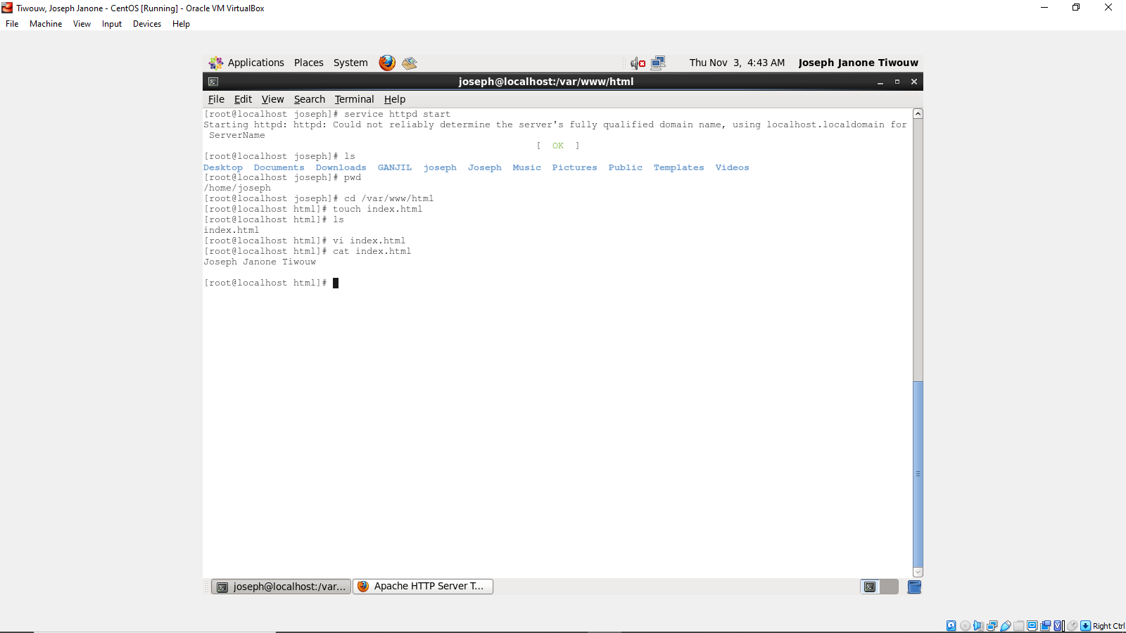
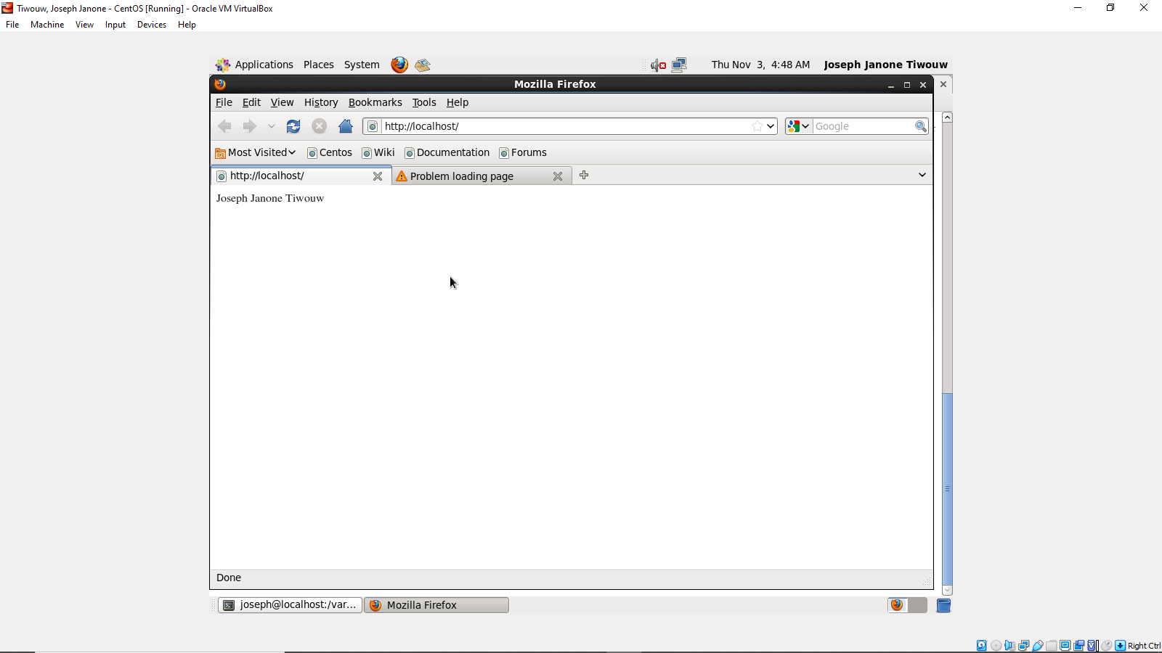

4.
